Bugs

פיצ'ר- מלונות בחו"ל

**title**-Bug gui in the orange box .

**Description-**

**1.**who enter to enter the orders details

**2**.appears on the right side of the clock in an orange box

**3.**inside the box there is an inscription

**Expected result-**

Should be registered

עוד קצת ואפשר להתחיל לארוז !

**Actual result-**

Registered

עוד קצת ואפשר להתחיל לארוזl

**Severity**

low

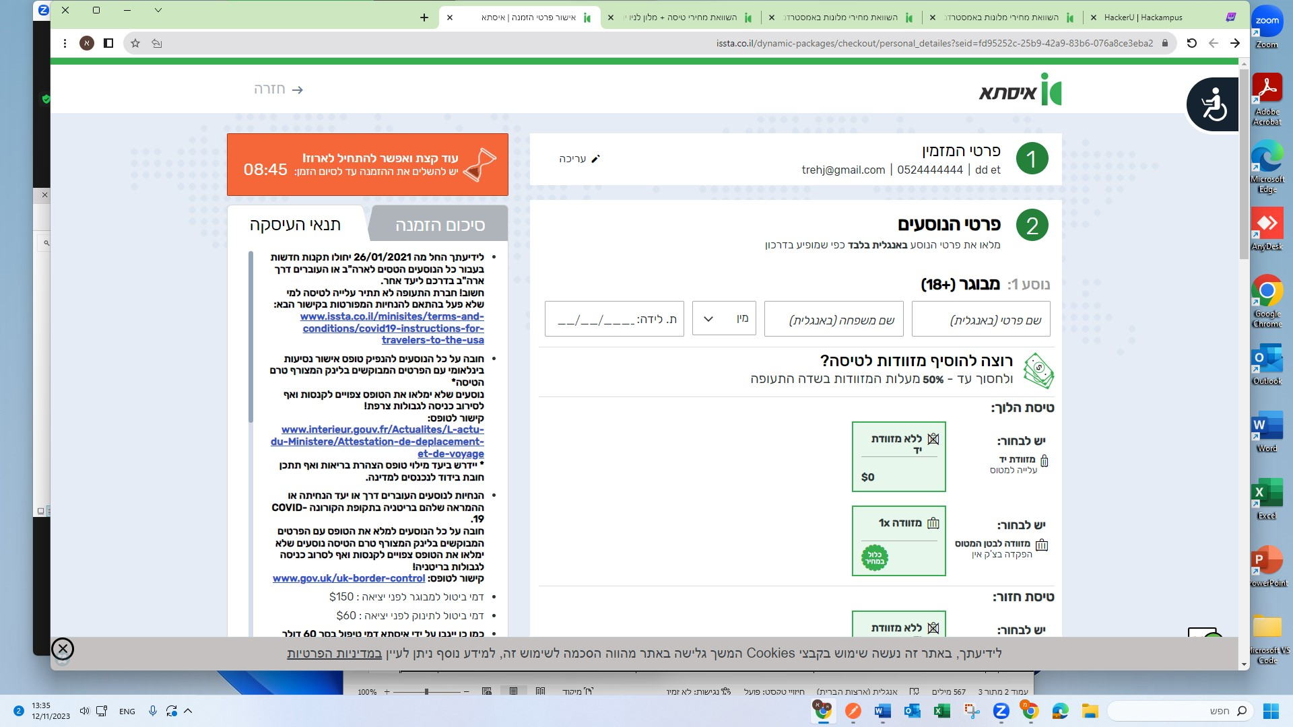

Bugs

**Title-**

In my favorites if you click on the heart to remove from the my favorites is hasnot been removed

**Description-**

On the picture of the hotel on the lower right, you can mark an favorite**1**

The heart is painted red**2**

**3** above where it says entry to the personal area

The arrow appears in my favorites**4**

I see the hotel I chose**5**

**6** In the picture above, a heart appears in red

you click on the heart to remove from the favorites**7**

outgoing from my favorites**8**

returns back to my favorites**9**

**Expected result-**

That the hotel will be removed from my favorites

**Actual result-**

The hotel has not been removed.

**Severity-**medium

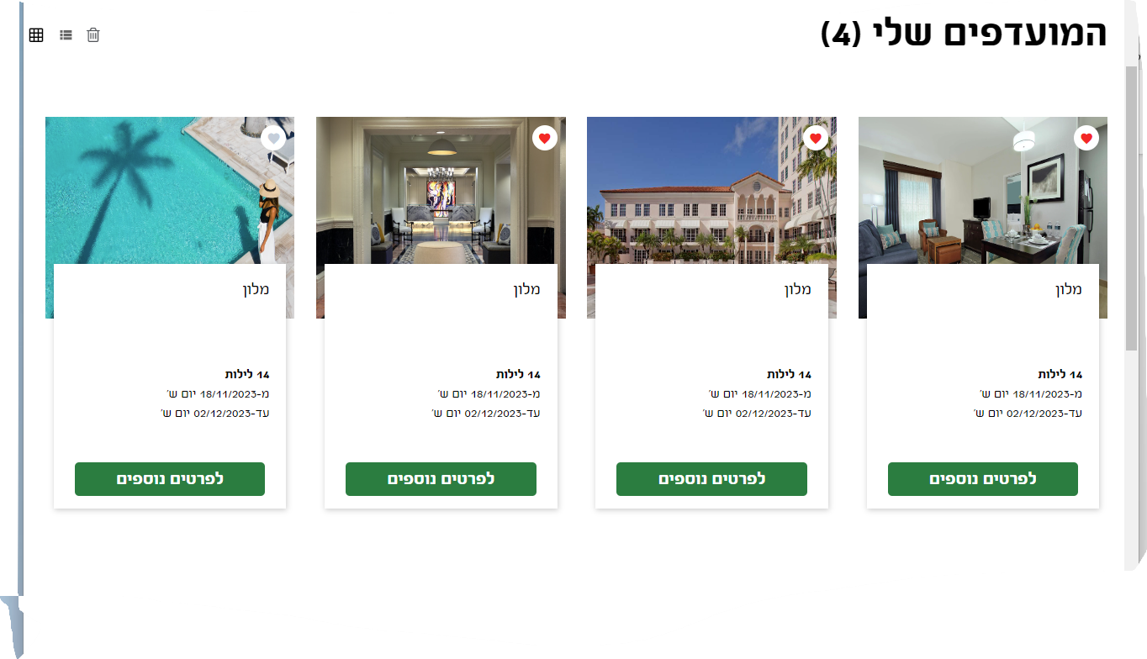

**Bugs**

I checked in browsers- google chrome, Microsoft edge

**Title-**

When changing flight-filter bar does not respond

**Description-**

**1**. choose a destination, date, and number of guests

ברלין גרמניה 20/11/23-31/12/23 2 אורחים

**2.**click on the button-

מצאו לי דיל בחו"ל

**3.** A number of search results will open, selects a hotel.

**4**. presses a button-

הזמן עכשיו

**5**. Next to the room selection button an option opens to click on a button including flight.

**6**. click on a button including flight

**7**. Open a row below to add a flight. Click on the add flight

**8**. We will open 2 option 1. change flight / 2. flight details

**9.** Click on change flight

**10**. Several options will open

**11**.a filter bar appears above who can choose-

מחיר, כמות עצירות ביניים, חברת תעופה, זמן המראה, משך עצירת ביניים

**Expected result-**

By clocking on the arrows there is a choice

**Actual result-**

The arrows do not respond, it is not possible to filter a selection.

**Sverity-**medium

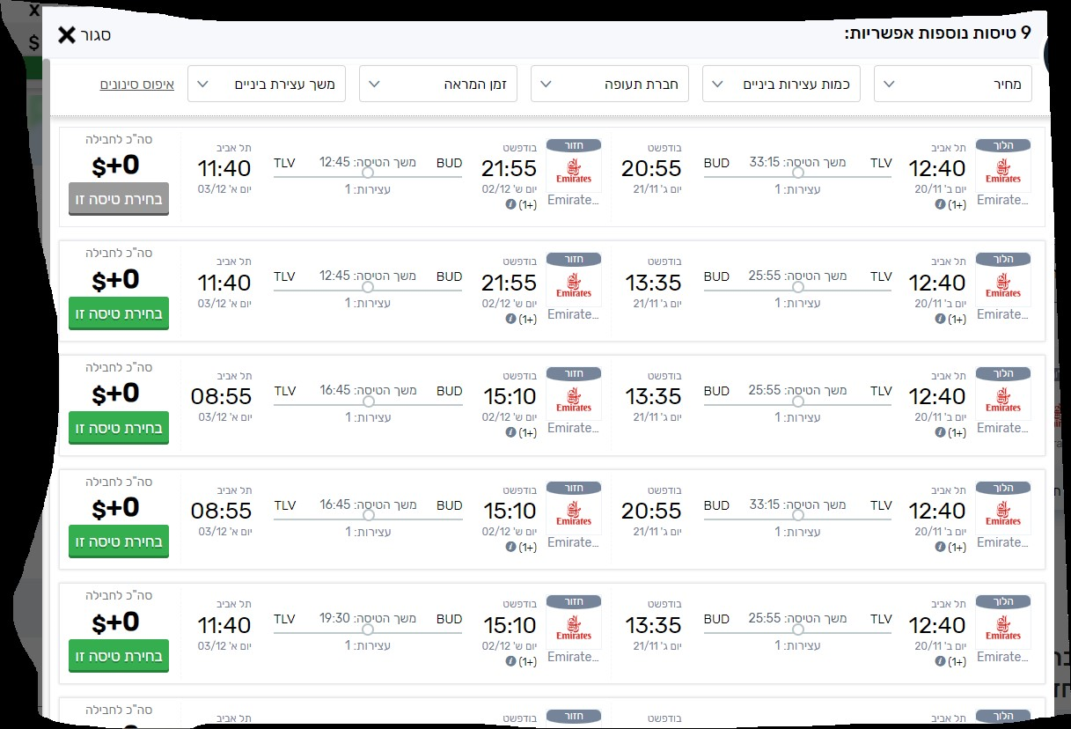

Bugs

**title**- Problem choosing the number of guests.

**Description-**

1. the hotels abroad

2. chooses a destination-

אמסטרדם,הולנד

3.choosing dates 14/11/23/15/11/23

4.guest selection-

1 adult

4 children aged (1,1,8,12)

5.i pressed a button-

חיפוש

**Expected result**

I will get search results for hotels

**Actual result-**

.i got a message-

מספר התינוקות חייב להיות קטן או שווה למספר המבוגרים.

**Severity**

High

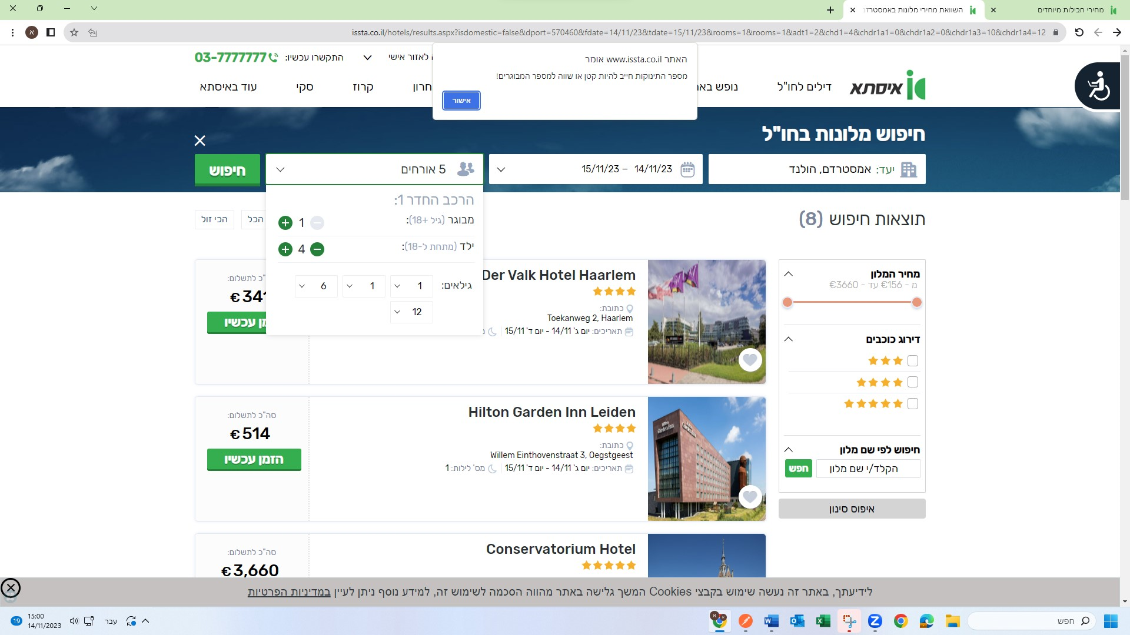

**Bugs GUI**

**Title-**

The search bar appears above the text. - GUI

**Description-**

**1**. choose a destination, date, and number of guests

בנגקוק תאילנד, 1/12/23-8/12/23 2 אורחים

**2.**click on the button-

מצאו לי מלון בחו"ל

**3.** A number of search results will open, selects a hotel.

**4**. presses a button-

הזמן עכשיו

**5** click above on

עריכה

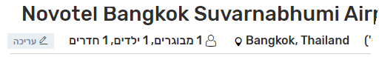

**6**.do not click x to close

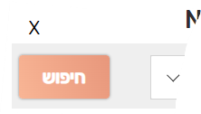

**7**.scroll down with the mouse

**Expected result-**

Let the writing be clear

**Actual result-**The search bar appears above the text.

**Severity-** low

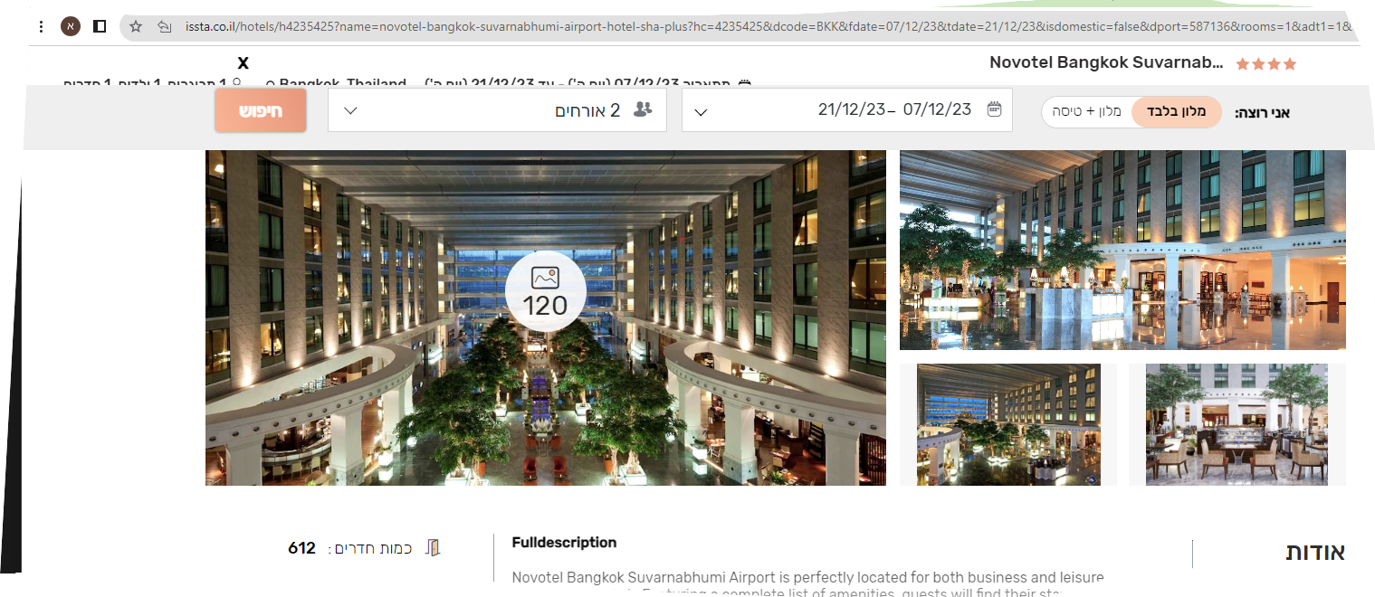

**Bugs on the iphone**

**iPhone 13 pro max I checked through google chrome**

**Title-**

An icon that can be called issta is not responding.

**Description-**

**1.** you enter a website

**2.**The wed is opened

**3**.on the top left there is a phone icon that you can call issta directly

**Expected result-**

Clicking on the icon calls the company.

**Actual result-**

The icon is not responding.

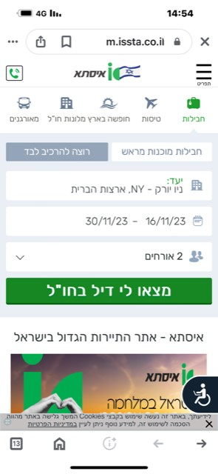

**Bugs on the iphone**

**iPhone 13 pro max I checked through google chrome**

**title**- unresponsive button-

שיתוף מלון עם אייקון של ווטסאפ

**Description-**

1.you enter a website.

2.the hotels abroad

3.choose where ,date ,and how many guests

4.you press a button-

מצאו לי מלון בחו"ל

5.you get several options

6.choose one hotel and click on the hotel

7.get details about the hotel

8.one the top right there is a button that can be clicked to share on WhatsApp

**Expected result-**

WhatsApp will open for sharing.

**Actual result-** The icon is not responding.

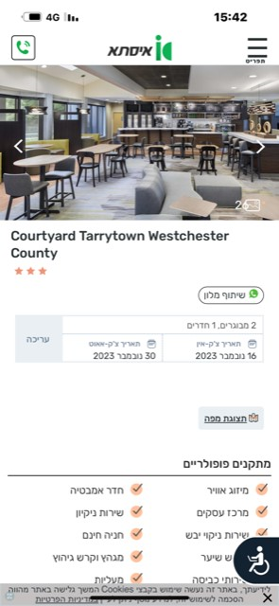

Bugs

**title**- nearby points of interest should be in meters

**Description-**

**1**.choosing -las vegas 7/12/23-21/12/23 **,**

2 guest

**2.**click on the button-

מצאו לי מלון בחו"ל

**3.** A number of search results will open, selects a hotel

**4.** click on the button-

הזמן עכשיו

**5**.click on the view map

**6**.and on the side are points of interest and their distance from the hotel

**Expected result-**

The distance should appear in meters and kilo meters

**Actual result-**

The distance appears in walking minutes

**Severity-** medium

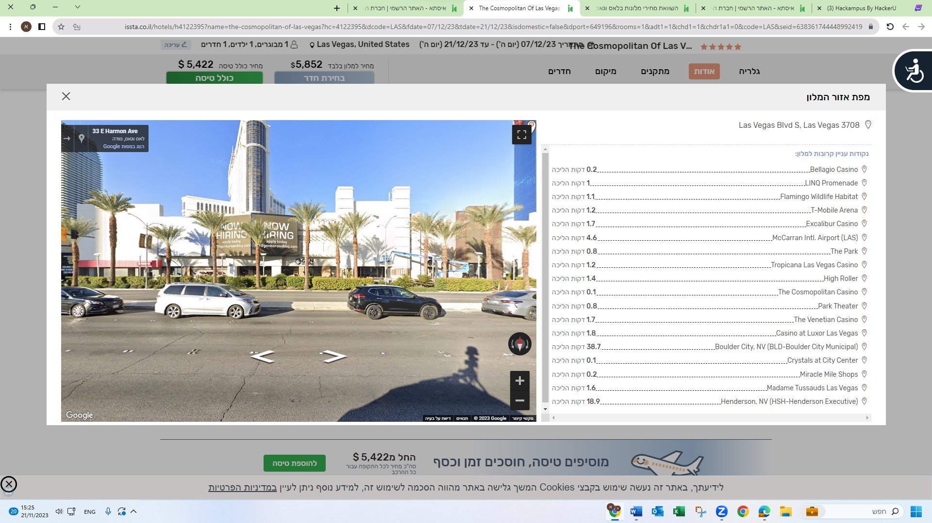

Bugs

השכרת רכב

**Title**-in my favorites in the button of

לפרטים נוספים, קיימת שגיאה בדף

**Description-**

**1.** The data typed-us

Los Angeles airport

26/12/23-31/12/23

גיל הנהג- 28

**2**. Click on the button-

מצאו לי רכב

**3**. Finds results

**4**. Click on the heart to add to favorites

**5**. above where it says entry to the personal area

**6**. The arrow appears in my favorites. See my favorites

**7**. Pressing down on-

לפרטים נוספים

**Expected result-**

Receiving-

אירעה שגיאה

אנו מתנצלים אך לא ניתן להציג את המידע המבוקש

**Actual result-**

To open details about the car

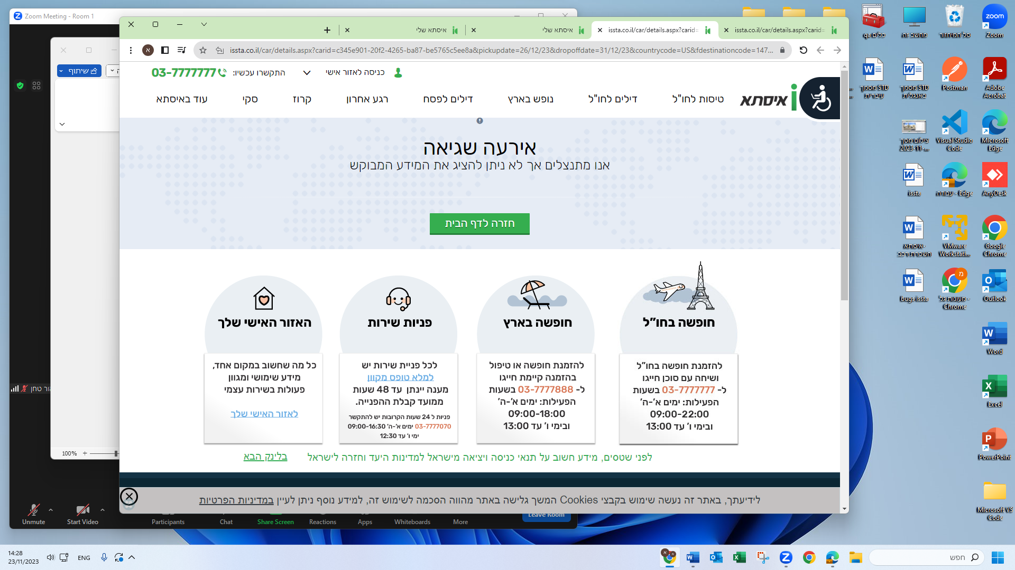

**I checked the data in dev tools**-Headers.

Status code- 404

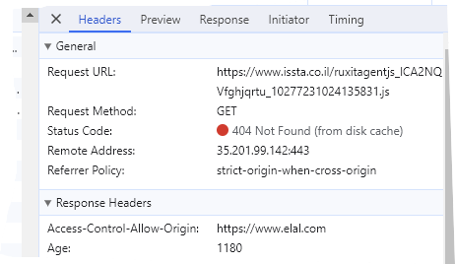

**Severity-**medium